# Building a Factory monitoring IoT pipeline. From source via MQTT into Apache Flink onto Fluss & Prometheus and visualized in Grafana.

IoT sensor readings in JSON format pushed onto MQTT, extracted using Flink MQTT source connector, flattened and into Fluss, inserted into Apache Flink tables configured with a Prometheus sink connector (BETA).

(17 June 2025)

# Overview

In a previous [blog](https://medium.com/@georgelza/a-factory-iot-instrumentation-data-stream-from-source-manipulated-using-pyflink-outputting-into-182c1ab85a7e) we explored ingesting our datastream from Apache Kafka, flattening it and sinking it into Fluss for real time and long term storage. We then further pushed out data stream to Prometheus, with a Grafana dashboard.

This time round I want to round off our industrial monitoring solution. We will be using MQTT brokers as our source of our metrics, from where our pipeline will consume and then process.

This blog will also be the culmination of this IoT data pipeline series, demonstrating the last component, sourcing directly from MQTT, thus bringing everything together.

We’re again taking a “[JSON](https://www.json.org/)” document representing a IoT based reading/measurement, structured as:

{

timestamp,

metadata {

labels1

labels2

labels3

},

measurement

}

for a sensor fitted to a machine, located in a factory and storing pushing the values into a [Prometheus TSDB](https://prometheus.io/), finally to be visualized via [Grafana](https://grafana.com/).

Well, that’s the 100 000 foot view.

Ok, before we go further. If you’ve been following my blog’s you’d say this sounds very much like a previous, and You’d be right, but then… You’d be wrong also, keep reading, you will find a fundamental difference in this one… And well, it’s been coming for a long time.

Now, let’s drill down a bit, this time we will first publish the readings onto 3 [MQTT](https://mqtt.org/) Brokers, each hosting a topic & each string readings for 2 factories.

As far as MQTT is concerned, as per their [web site](https://mqtt.org/):

*MQTT is an OASIS standard messaging protocol for the Internet of Things (IoT). It is designed as an extremely lightweight publish/subscribe messaging transport that is ideal for connecting remote devices with a small code footprint and minimal network bandwidth. MQTT today is used in a wide variety of industries, such as automotive, manufacturing, telecommunications, oil and gas, etc.*

From here we will source from the topics using Apache Flink tables configured using [MQTT Flink Source connector](https://github.com/georgelza/MQTT-Flink-Source-connector.git).

Yes, we wrote this [connector](https://github.com/georgelza/MQTT-Flink-Source-connector.git) in another [blog](https://medium.com/p/54e3f54fd2d5) ([GIT Repo](https://github.com/georgelza/MQTT-Flink-Source-connector.git))… just so that we can get this one done… As said before, world is full of Rabbit holes.

From here we then replicate the flow as per our previous blog, starting with flattening the nested structure of the IoT structure and store the flattened payload into a common Fluss table.

Next up we will source from our [Fluss](https://alibaba.github.io/fluss-docs/) table and sink into our [Prometheus](https://prometheus.io/) TSDB using our connector.

Lastly, we will use [Grafana](https://grafana.com/) to display our metrics.

## Regarding our data.

I grouped the factories (referred to as sites) into 3 sets:

* North (siteId 101 and 104)
* South (siteId 102 and 105)
* East (siteId 103 and 106)

(simulating a sort of regional distribution, depending where in the world you are, think states, provinces etc.). Each factory (site) has multiple devices, aka machines, each machine will have multiple sensors.

## Regarding Stack:

This time round we have a 3 separate MQTT Brokers, and as per previous our Apache Flink cluster and a Fluss cluster environment and then our Prometheus and Grafana stack.

Regard our Fluss stack. I simply did not configure (run) the lakehouse sink to our deep storage, based [Apache Paimon](https://paimon.apache.org/) open tables format stored on HDFS layer, for these labs as we’ve shown that working in the previous blog.

Our data is again generated by our [Python](https://www.python.org/) application, the main code base is location in <*root>/app_iot1,* which can be run via the following 3 shell scripts:

* *<root>/app_io1/site1.sh*
* *<root>/app_io2/site2.sh*
* *<root>/app_io3/site3.sh*
* The first *app_iot1* creates our simplest IoT JSON payload, for the north located sites
  + This is accomplished by setting *TSHUMAN, STRUCMOD & DEVICETYPE* = 0
* In *app_iot2* we extend the payload to include *TSHUMAN*=1 and *STRUCMOD*=1, for the south located sites.
  + This adds a human readable date field and the location object to the metadata tag section.
* In *app_iot3* we go one step further and add *DEVICETYPE=1* to the payload, for our east located sites.
  + This adds a text string defining the device type.

For catalog services we will be using the [Apache Hive](https://hive.apache.org/)’s and their [Metastore](https://cwiki.apache.org/confluence/display/hive/design#Design-Metastore) functionality as created in a previous blogs (but with a little version update applied recently).

For those that have been following my previous blogs, the [Apache Flink](https://flink.apache.org/) environment is now based 1.20.1. The [Apache Paimon](https://paimon.apache.org/) stack has also been upgraded to 0.9.0, Fluss 0.6.0.

For this build we now also have [Prometheus](https://prometheus.io/) (v3.3.0) and [Grafana](https://grafana.com/) (11.6.1)

As always, all the code can be found in the [GIT repository](a/DataPipeline-MQTT_Fluss_Prometheus.git), and yes, we’re still using a substantial amount of *Makefiles*, *Docker-compose.yml* and *Dockerfile’s*.

## Simple Overview Diagram

On the High-Level Source side, we have.

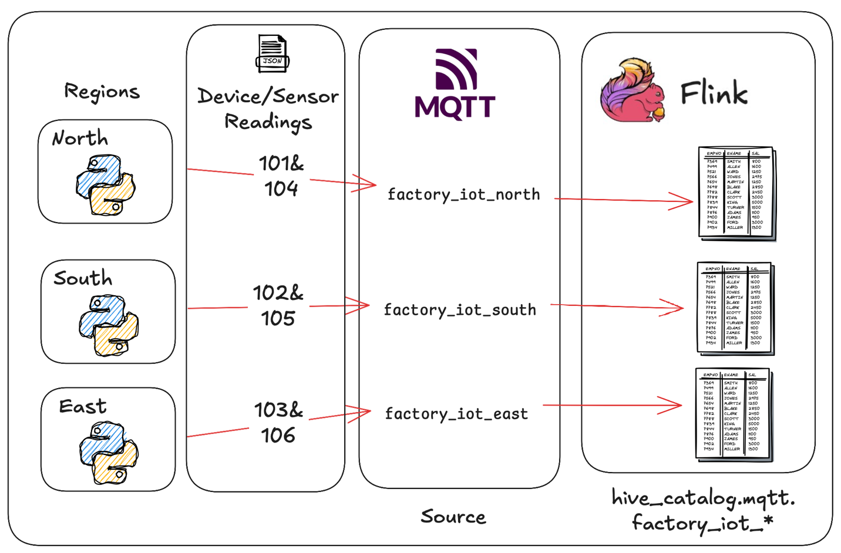

If we zoom out a bit, we can see the entire project…

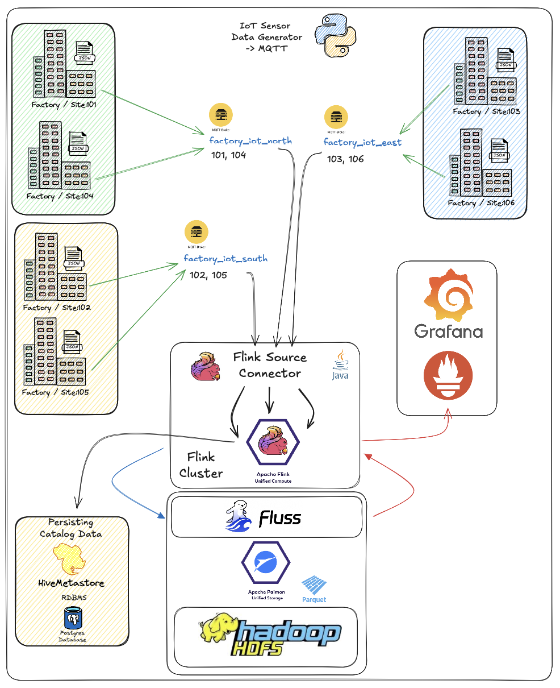

Once the scaffolding is up, this is it, and this is all of it. Of course you can make it allot more complicated.

To start navigate to the *<root>* folder and read the *README.md* file. This will give a similar overview as per above, that will then direct you to build the basic scaffolding using (<*root>/infrastructure/),* after which you will be directed to *<root>/devlab0/README.md* instructing you how to build and run the various examples.

## Regarding our payloads

Our first region is been naughty, they are populating the absolute minimum tags of our IoT JSON document.

Executing */<root>/app_iot1/site1.sh>* will thus produce the below document.

{

"ts" : 123421452622,

"metadata" : {

"siteId" : 1009,

"deviceId" : 1042,

"sensorId" : 10180,

"unit" : "Psi"

},

"measurement" : 1013.3997

}

Below we have the second region, they seem to have read the documentation/expectations a bit more and populated more of the fields of our IoT JSON document.

Region South data is generated using *<root>/app_iot2/site2.sh* application. This as you can see below adds the *ts_human* and *location* object to the payload.

{

"ts" : 123421452622,

"metadata" : {

"siteId" : 1009,

"deviceId" : 1042,

"sensorId" : 10180,

"unit" : "Psi",

"ts_human" : "2024-10-02T00:00:00.869Z",

"location": {

"latitude": -26.195246,

"longitude": 28.034088

}

},

"measurement" : 1013.3997

}

And lastly as we’re feeling very lucky, the East Region paid attention, and they are providing us a complete IoT Document.

To generate their payload, execute *<root>/app_iot3/site3.sh* application which will add the *deviceType* field to the metadata tag.

{

"timestamp" : "2024-10-02T00:00:00.869Z",

"metadata" : {

"siteId" : 1009,

"deviceId" : 1042,

"sensorId" : 10180,

"unit" : "Psi",

"ts_human" : "2024-10-02T00:00:00.869Z",

"location": {

"latitude": -26.195246,

"longitude": 28.034088

},

"deviceType" : "Oil Pump",

},

"measurement" : 1013.3997

}

So we now have an overview of the 3 payloads and how to generate them at the source end.

We will have 2 catalogs, namely:

* *hive_catalog* with a *kafka* and *prometheus* database and then
* *fluss_catalog* containing the *fluss* database.

The Apache Flink Cluster to Fluss cluster link is accomplished by specifying the *bootstrap.servers = ‘coordinator-server:9123’* in the catalog definition as per below:

CREATE CATALOG fluss_catalog WITH (

'type' = 'fluss',

'bootstrap.servers' = 'coordinator-server:9123'

);

We have primarily 3 steps in ours pipeline;

* Ingest into Apache Flink from MQTT via our Apache Flink MQTT Source Connector
* Flatten into Fluss table
* Insert into Flink Table representing sink into Prometheus

## Top to Bottom.

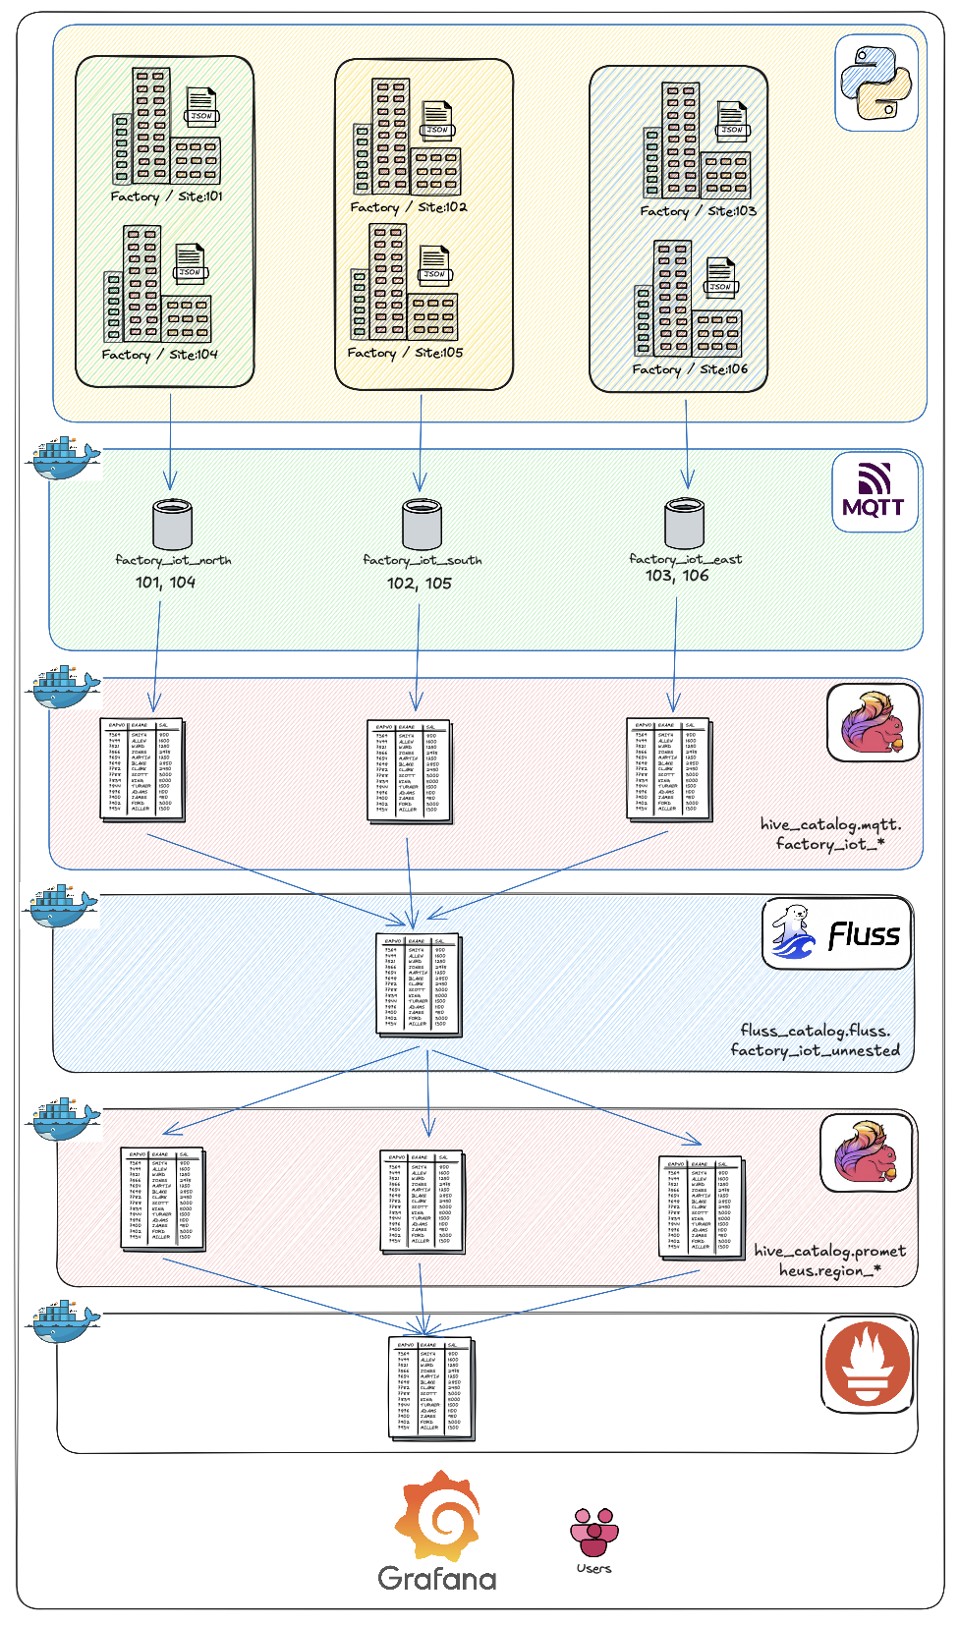

# Source to MQTT via connector into Apache Flink (step 1):

This is our Source step.

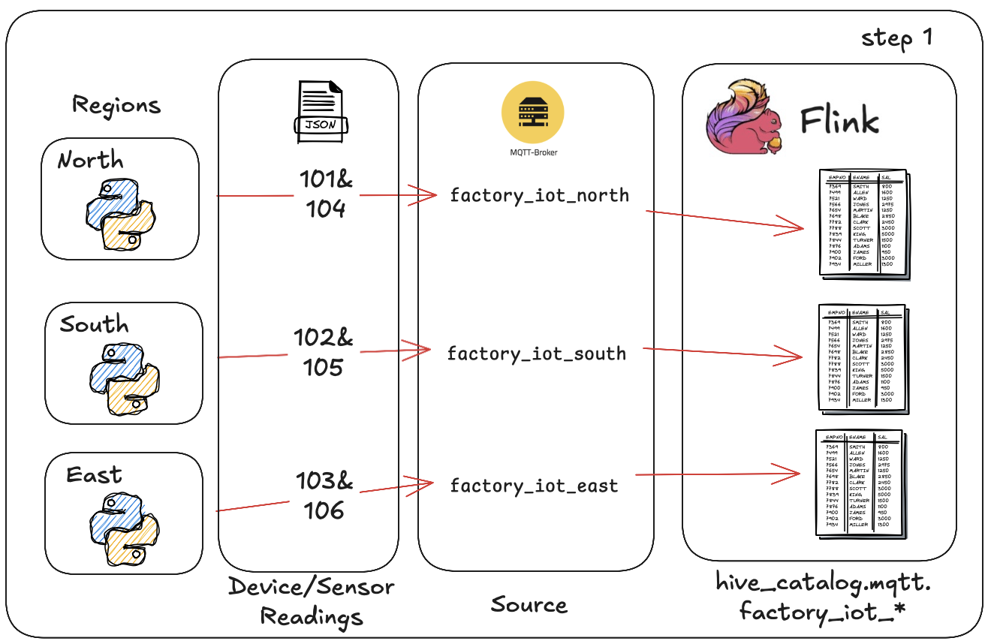

This is accomplished using the following Flink SQL. You will find there are 3 create sections in the below SQL script. One for each region. This will use our Apache Flink MQTT Source Connector as created in our other blog.

See: <*root>/devlab0/creFlinkFlows/2.1.creKafkaSource.sql*

CREATE OR REPLACE TABLE hive_catalog.mqtt.factory_iot_101 (

ts BIGINT,

metadata ROW<

siteId INTEGER,

deviceId INTEGER,

sensorId INTEGER,

unit STRING,

ts_human STRING,

location ROW<

latitude DOUBLE,

longitude DOUBLE>,

deviceType STRING>,

measurement DOUBLE,

ts_WM AS TO_TIMESTAMP(FROM_UNIXTIME(CAST(`ts` AS BIGINT) / 1000)),

WATERMARK FOR ts_WM AS ts_WM

) WITH (

'connector' = 'mqtt'

,'broker.host' = 'broker_north' -- Example: your MQTT broker's hostname or IP

,'broker.port' = '1883' -- Example: your MQTT broker's port (1883 for non-SSL)

,'topic' = 'factory_iot/north/101'

,'format' = 'json'

,'client.id' = 'flink_iot_north_101_consumer'

,'qos' = '1' -- QoS, 0, 1 or 2

,'username' = 'mqtt_dev'

,'password' = 'abfr24'

,'automatic-reconnect' = 'true' -- Valid boolean value ('true' or 'false')

,'clean-session' = 'true' -- Valid boolean value ('true' or 'false')

,'ssl' = 'false' -- Set to 'true' if using SSL and configure below

);

At this point we can run the following commands which resulted in results as per screen grabs.

use hive_catalog.mqtt;

select * from hive_catalog.mqtt.factory_iot_101;

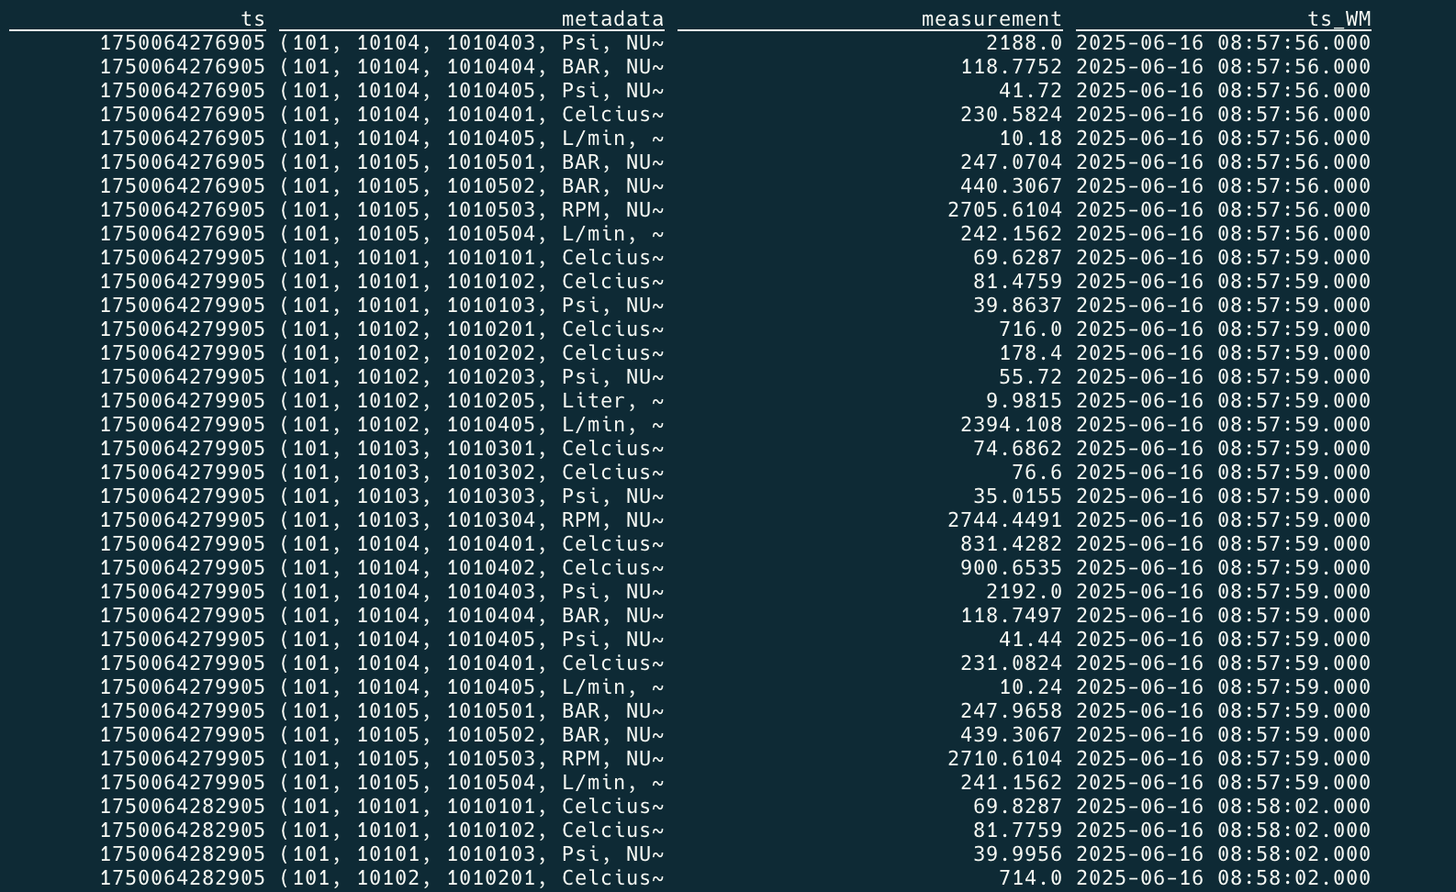

select ts, metadata.siteId, metadata.deviceId, metadata.sensorId, metadata.unit, metadata.ts_human, metadata.location.latitude, metadata.location.latitude, measurement, ts_WM from factory_iot_103;

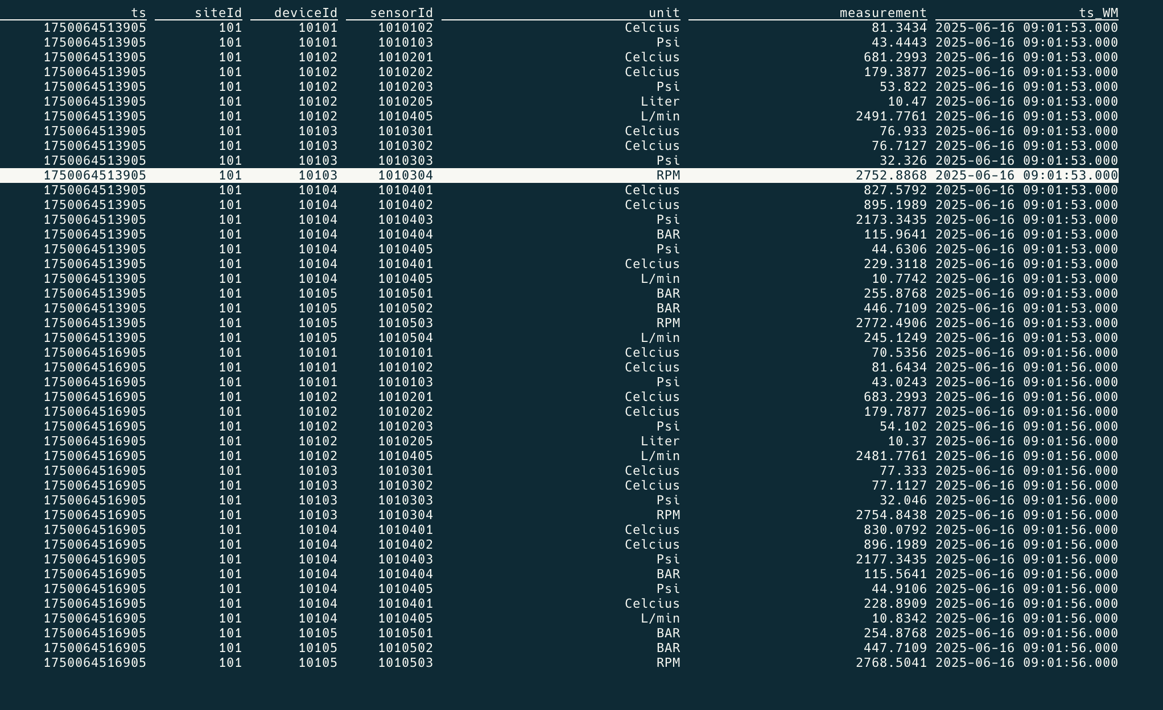

# Convert/Flatten into Fluss table (step 2):

Here we will flatten our structure into our Fluss environment.

Even though we not deep storing the data into the lakehouse tier, this is an option in production, allowing for deep analytics, AI, ML etc.

We can even use the Apache Flink, Pyflink capabilities as per the previous blog to do additional aggregation, or calling external API’s.

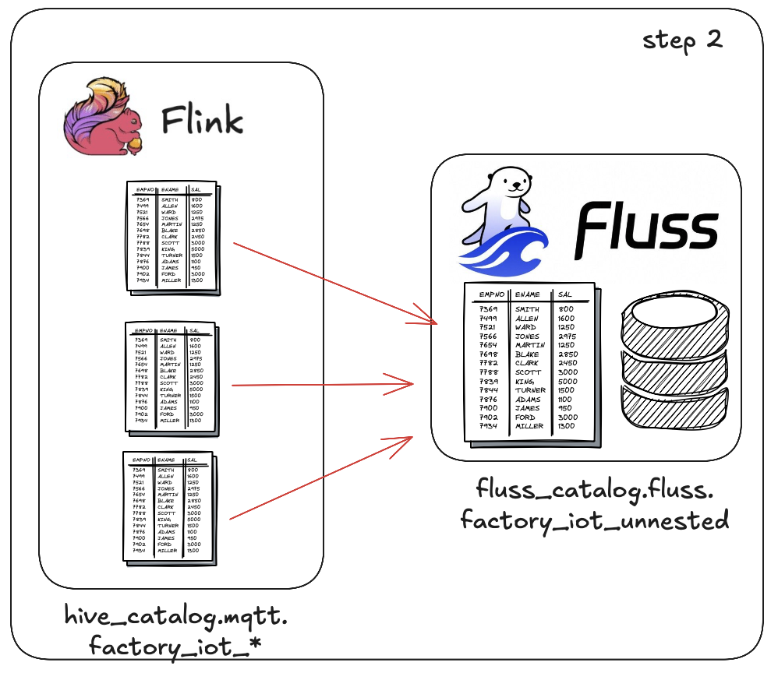

We first need to create our Fluss target table, this is accomplished using the following Flink SQL. For the Fluss tier we have a single table.

See: <*root>/devlab0/creFlinkFlows/2.2.creFlussTarget.sql*

CREATE OR REPLACE TABLE fluss_catalog.fluss.factory_iot_unnested (

ts BIGINT

,siteId INTEGER

,deviceId INTEGER

,sensorId INTEGER

,unit STRING

,ts_human STRING

,longitude DOUBLE

,latitude DOUBLE

,deviceType STRING

,measurement DOUBLE

,partition_month STRING -- must be provided by upstream or insert logic

,ts_wm AS TO_TIMESTAMP_LTZ(ts, 3)

,WATERMARK FOR ts_wm AS ts_wm - INTERVAL '1' MINUTE

) PARTITIONED BY (partition_month) WITH (

'bucket.num' = '3'

,'table.datalake.enabled' = 'true'

,'table.auto-partition.time-unit' = 'MONTH'

,'table.auto-partition.num-retention'= '60'

);

We can now push from our step 1 tables into the Fluss table using the following Flink SQL. Again I’m only showing one insert, see the below script for the 3 insert statements.

See: <*root>/devlab0/creFlinkFlows/3.3.creFlussInserts.sql*

INSERT INTO fluss_catalog.fluss.factory_iot_unnested

(ts, siteId, deviceId, sensorId, unit, ts_human, longitude, latitude, deviceType, measurement, partition_month)

SELECT

ts AS ts

,metadata.siteId AS siteId

,metadata.deviceId AS deviceId

,metadata.sensorId AS sensorId

,metadata.unit AS unit

,CAST(NULL AS STRING) AS ts_human

,CAST(NULL AS DOUBLE) AS longitude

,CAST(NULL AS DOUBLE) AS latitude

,CAST(NULL AS STRING) AS deviceType

,measurement AS measurement

,DATE_FORMAT(TO_TIMESTAMP_LTZ(ts, 3), 'yyyyMM') AS partition_month

FROM hive_catalog.mqtt.factory_iot_101;

# Sink into Prometheus (step 3)

Some notes first. Our data generator can be configured to create historic data or not… Why the or not, well Prometheus don’t directly accept historic data. To disable our history data generate functionality see <*root>/app_iot#/site#.sh*

Edit/set: *RUNHISTORIC=0*

This will disable our historic data generation loop.

If curious, with regard to loading historic data into your Prometheus environment see the <*root>/otl/README.md* file.

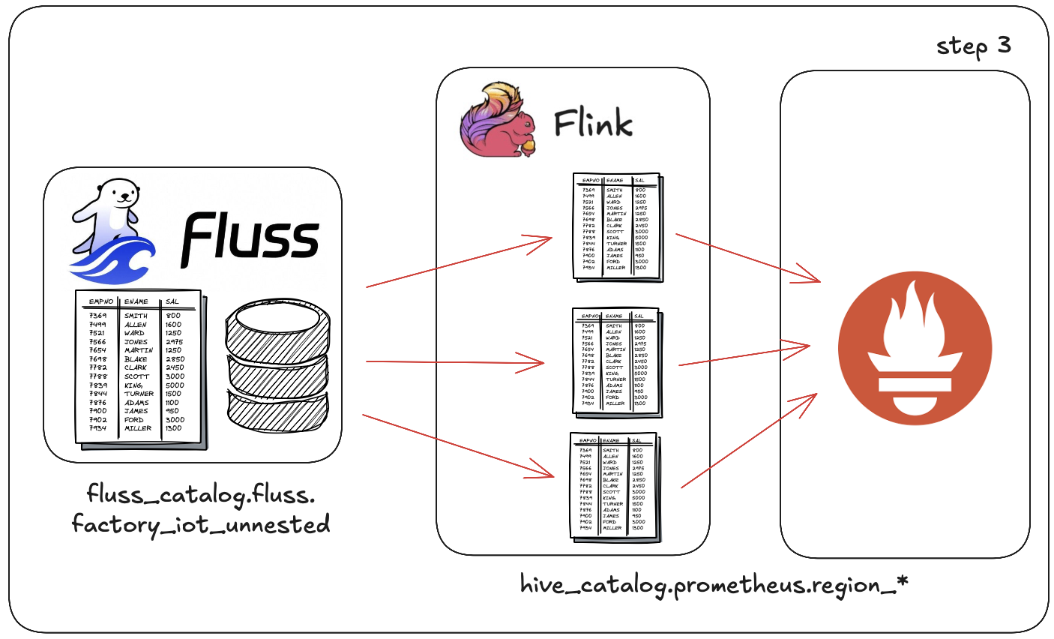

We first need to create our Prometheus target table/s, this is accomplished using the following Flink SQL (i.e: *region*_*north* table), we have similar for “*region_south*” and “*region_east*” tables.

See: <*root>/devlab0/creFlinkFlows/2.2.crePromTarget.sql*

CREATE TABLE hive_catalog.prometheus.region_north (

`metric_name` STRING

,`sensorId` INT

,`siteId` INT

,`deviceId` INT

,`measurement` DOUBLE

,`ts` TIMESTAMP(3)

) WITH (

'connector' = 'prometheus'

,'metric.endpoint-url' = 'http://prometheus:9090/api/v1/write'

,'metric.name' = 'metric_name'

,'metric.label.keys' = '[sensorId,siteId,deviceId]'

,'metric.sample.key' = 'measurement'

,'metric.sample.timestamp' = 'ts'

);

If you look at the below SQL you will see we will have 3 separate Insert jobs, each specifying *sensor_readings* as the metric name into the separate tables.

We do have the option to rather create a single target Prometheus table and then called the metrics:

* “*region_north*” and changing the where to *siteId=101* and *siteId=104* and
* “*region_south*” and change the where to *siteId=102* and *siteId=105* and
* “*region_east*” and changed the where to *siteId=103* and *siteId=106*

or even split it further i.e.: and called the metric per site: “*sensor_readings_site01*”.

Note the connection does cater for batching based writes by way of some additional variables/settings, see the connector PR for this. This blog will be updated once the connector is officially released.

For now, for the blog we will run 3 Flink tables, one per region and for source use a single sites records from our *factory_iot_unnested* table located on our Fluss cluster.

See: <*root>/devlab0/creFlinkFlows/3.2.crePromInserts.sql*

INSERT INTO hive_catalog.prometheus.region_north

(metric_name, siteId, deviceId, sensorId, measurement, ts)

SELECT

CAST('sensor_reading' AS STRING) AS metric_name

,siteId AS siteId

,deviceId AS deviceId

,sensorId AS sensorId

,measurement AS measurement

,TO_TIMESTAMP(FROM_UNIXTIME(ts / 1000)) AS ts

FROM fluss_catalog.fluss.factory_iot_unnested

WHERE siteId=101;

Once you have the above configured you can navigate to <http://localhost:9090>. Click on graph tab and enter the text as per below and click execute.

# Prometheus

## Prometheus Graph – Device view

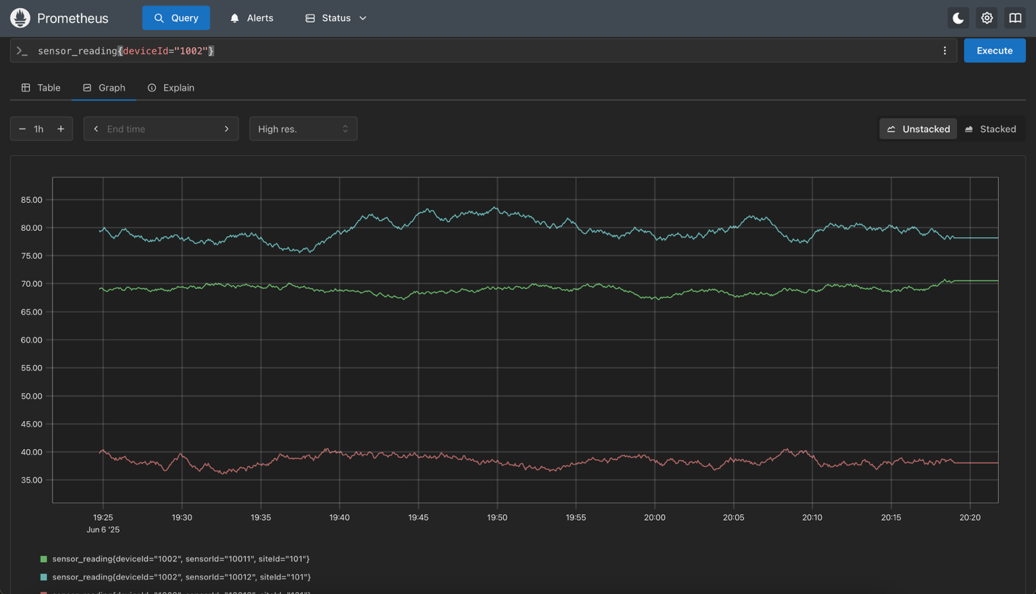

## Prometheus Graph – Sensor view

Once you have some data showing as per above you can click on one of the metric streams to drill down into that metric as show next.

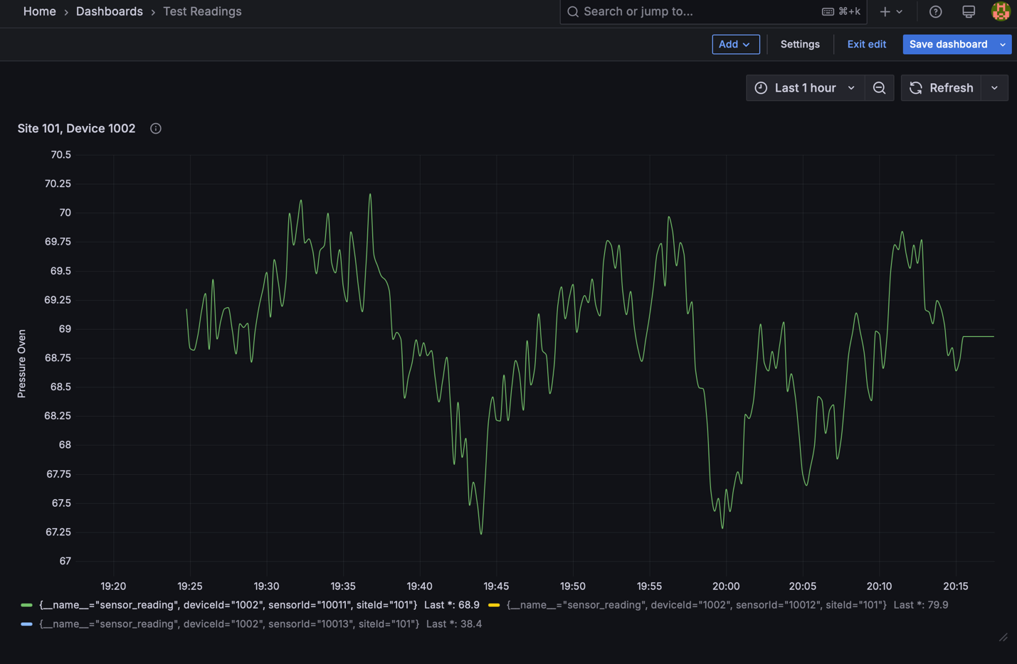

# Grafana Dashboard

Lastly, I configured a Grafana dashboard (see <*root>/devlab0/Grafana/*) for the JSON file that can be imported into Grafana after you configured a “Prometheus” data source.

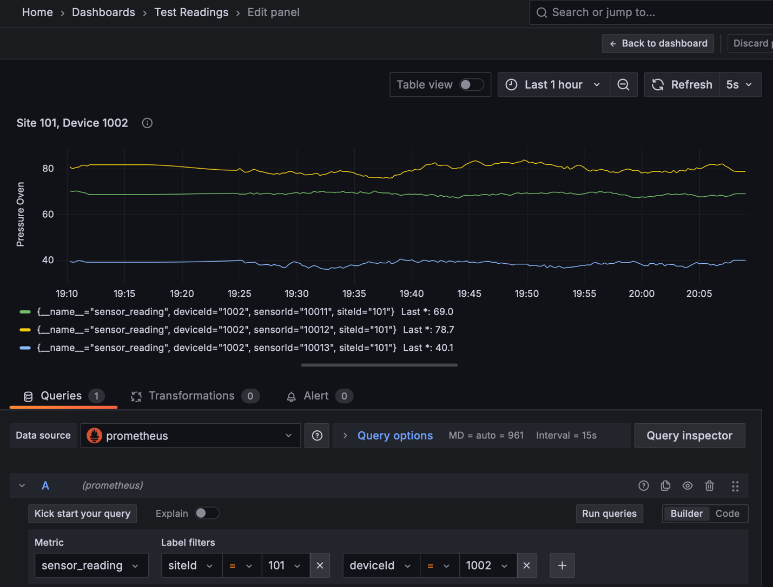



# And In Summary.

What can I stay, this one has been long time in the making.

It’s completed.

We now have a IoP based message from source to multiple targets, based on a real time industrial IoT pipeline using the very common lightweight MQTT protocol as our transport layer.

We then use various Apache Flink capabilities, i.e.: PyFlink to show how we can potentially do external AI and ML calls, added to that we have shown some “simple’ aggregation, and windowing via Apache Flink SQL.

We have further introduced the reader to real time (and long term lakehouse) storage using Fluss as our Open Table format, using industry recognized Apache Parquet files for storage on HDFS or S3.

And then shown an operational centre monitor option using Prometheus and visualization via Grafana.

As always, I’m predictable, but I really do think this is pretty amazing… Hope you enjoyed the exploration, the journey up to now.

The next idea is brewing already ;)

Good luck, this is all fraught with rabbit holes, as always, so many and you can disappear so easily… but then that’s ½ the fun.



*Note: to execute this blog start with README.md located in the root folder and work from there, it will tell you exactly what to execute in which order to download all the dependencies and build everything. If you have any problems, welcome to reach out to me via one of the below profiles.*

**About Me**

I’m a techie, a technologist, always curious, love data, have for as long as I can remember always worked with data in one form or the other, Database admin, Database product lead, data platforms architect, infrastructure architect hosting databases, backing it up, optimizing performance, accessing it. Data data data… it makes the world go round.

In recent years, pivoted into a more generic Technology Architect role, capable of full stack architecture.

[George Leonard](https://www.linkedin.com/in/george-leonard-945b502/)

[georgelza@gmail.com](mailto:georgelza@gmail.com)

<https://www.linkedin.com/in/george-leonard-945b502/>

<https://medium.com/@georgelza>